**Git Process for Multi-person Collaborative Development**

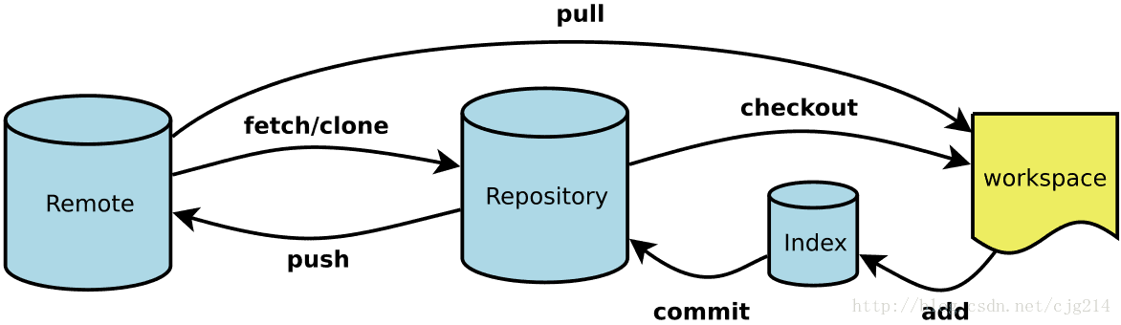

Git Command

When multiple people work together, the main (master) branch and dev branch are usually on GitHub at the beginning of the project, and the ‘main (master)’ branch is the main branch, which is directly associated with the final released program, and each developer cannot directly push the program To the main branch, it can only be pushed to the dev branch. After testing without any problems, it will be finally pushed to the main branch by a special person. Each developer needs to create their own branch based on the dev branch.

# For example:

The project team members are Zongyang and Simon, and Zongyang is the project leader.

## Step1: creates a repo

The project leader creates a repo called gitTest on GitHub and add Simon.

## Step2: create two branches.

Init project，create two branches named ‘main’ and ’dev’

$ git init

Create a text file a.txt, and add text ‘zongyang init’;

$ git add .

$ git commit -m "init"

$ git remote add origin https://github.com/zongyanggong/gitTest.git

$ git push origin master

$ git checkout -b dev

$ git push --set-upstream origin dev

Then, there are two branches on GitHub, master, and dev.

## **Step3：**clones the project.

### 3.1 Project member Simon clones the project.

$ git clone https://github.com/zongyanggong/gitTest.git

Check local repository:

$ git branch

### 3.2 At this moment, there is only one branch: master. Simon needs to fetch ‘dev’ branch。

$ git fetch origin dev:dev

Meaning: fetch remote ‘dev’ branch to local repository.

### 3.3 Create local developing branch：

$ git checkout -b simon_test

Edit a.txt file and add word “Simon created”.

$ git add .

$ git commit -m “Simon created”

$ git push origin simon_test

Now, simon_test branch was added on GitHub and content in a.txt file was changed.

But a.txt in dev branch did not change.

### 3.4 Update dev branch:

$ git checkout dev

$ git merge simon_test

$ git push origin dev

Then the a.txt in dev branch on GitHub was changed。

## Step4：daily work flow (Take Simon for example)

### 4.1 Fetch latest content in dev before work

For example, a.txt file has been added one line by Zongyang “add by zongyang”. Now a.txt file in dev branch has already been updated, but a.txt file in simon_test branch is not the latest version.

$ git checkout dev

$ git pull origin dev

Now if dev branch has new version, Simon should checkout to his local branch and update it.

$ git checkout simon_test

$ git merge dev

Then, his local branch’s a.txt file has updated to the same version as dev。

$ git push origin simon_test

The a.txt file in simon_test branch on GitHub has been updated.

### 4.2 Push code to your own branch simon_test

You can directly push the content of your own branch simon_test at any time during the work process.

### 4.3 Push your work back to the dev branch.

When get off work or a function has been solved, you need to push your work to the dev branch.

$ git add .

$ git commit -m “simon add a=1”

$ git push origin simon_test

At this time, the a.txt file under the simon_test branch on GitHub is updated, but the a.txt file under the dev branch has not been updated yet.

If Zongyang has updated the content of the a.txt file currently, add a line "add by zongyang a=2".

Currently, the content under the dev branch on GitHub is inconsistent with the content of Simon's local dev branch. Simon locally switches to the dev branch first,

$ git checkout dev

The content of a.txt under the dev branch is:

Therefore, every time Simon needs to update the content of the dev branch, he first needs to pull the content of the dev branch on GitHub, to ensure that the local dev branch file is up to date before merging.

$ git pull origin dev

Then open the local a.txt file, which is consistent with the a.txt file on GitHub.

Then merge the files under the simon_test branch into the dev branch:

$ git merge simon_test

At this time, a conflict will be prompted, and the conflict needs to be resolved manually. Open the local a.txt file:

At this point, you can add and commit the dev branch and push it to GitHub.

$ git add .

$ git commit -m “simon add a=1”

$ git push origin dev

Switch to the simon_test branch:

$ git checkout simon_test

$ git merge dev

Now open the local a.txt file, the content has changed.

$ git push origin simon_test

Currently, the content under the simon_test branch on GitHub is updated.

Benefits of such a process:

1. There is almost no conflict.

2. Never pollute the dev branch. Because every time the local merger is completed and the conflict is cleared, the push will go to the remote end. Then when someone updates the local dev branch and then merges, even if there is a conflict, it will only be a conflict generated by the latest code.

Finally, let's clarify our thinking again.

1. During official development, each person only needs to have two local branches. One is called dev, and the other is your own branch.

2. Everyone can directly push code to their own branch. But when pushing the dev branch. The latest remote dev branch must be pulled first. Then merge with the local branch, and push after clearing the conflict. Currently, add and commit are required.

3. After submitting the dev branch, update the respective branches on GitHub. At this time, only merge and push are needed, and add and commit are not required.